2024 HOMECOMING PARADE PARTICIPANT GUIDE
Dear Parade Participant,
For the past one-hundred and four years, Penn State students have come together to participate in a celebration of a school that has given us some of our fondest memories, experiences, and friends. Homecoming Week is a week of pride, community, and celebration, and no one does it better than us. I cannot wait to see all the community accomplishes this year, and create some of the best homecoming memories to remember for years!
This parade participant guide was put together to educate you on the regulations and guidelines we have created to ensure that you have a wonderful time in the homecoming parade and that everything runs smoothly, so please be sure to read this entire document. We’re hoping this guide will answer most of your questions, but do not hesitate to reach out to me, the Parade Director, at paradehomecoming@psu.edu. Also, the entire Homecoming Executive Committee and all the parade captains are happy to serve as a resource for you throughout the year.
The theme for Homecoming 2024 is “In Every Roar, Tradition Soars”. As a Penn Stater, everyone has a roar within them that shows their Penn State pride, which we strive to show this homecoming. Thank you for the time and dedication you will put into this year, and again, I cannot wait to see how everything turns out. We Are!
For the Glory,
Olivia Markus

Table of contents
Section I……………………………………...Overview of Participant and Arrival Time Guides
Section II…………………………………………………………….Directions for having a Float
Section III…………………………………………………………Directions for having a Vehicle
Section IV………………………………………………………………….Directions for Walkers
Section V……………………………………………………………….Payment Options and Cost
Section VI……………………………………………………………………………..Expectations
Section VII………………………………………………………………………………...Penalties

Section I
Overview of Participant and Arrival time guidelines
After you have registered, you will receive a confirmation email to ensure we have received your information. This email will also include information about the payment process that will need to be completed later on to participate. Please allow 24 to 48 hours for this email to be sent. If you have any questions, feel free to email the parade captain that sent you your confirmation email. Closer to the parade date, you will receive an email providing you with information regarding where and when your group should sign in on parade day. Please let us know ASAP if your time does not work, but only as a last resort. We’ve given you a check-in time that takes into consideration several factors such as where you are located in the parade order, your group size and where you can best be accommodated, so please try to find a way to check in at your time. Once you sign in, it is extremely important that someone is with your vehicle, float, or your allotted waiting area for walking groups at all times. We understand that waiting can get boring, but we have created this system to make sure the parade runs as smoothly as possible. If someone in your group does not show up for your scheduled time, unfortunately, we will not be able to allow you to walk in the parade, and no refund will be given. If you have any inquiries leading up to the parade, do not hesitate to reach out to any of the parade captains, or the parade director.
Section II
Directions for having a Float
If you plan on participating in the parade with a float, please contact floatparadehomecoming@psu.edu with any questions. On parade day, you will take your float to the float grounds at the allotted time given to you to check in. Float grounds is located behind Medlar Field, down the road from the Blue Loop Stop, away from the stadium. See the map below for the float grounds location as well. Once checked in, you will be directed to a parking spot on the grounds, someone will need to stay with the float at all times. If you have an early check-in time, I recommend finding a few other people that can switch with you, so that you are not stuck there all day. Once the lineup for the parade starts, homecoming captains will help you get into the correct spot in line, and you will drive your float to “merge point,” where we meet with all other participants. If you also have walkers joining you during the parade, don’t worry!
We work very hard to make sure everyone in your group is put together in the parade, which is why it is very important to listen to the captains so that you are in the correct spot.
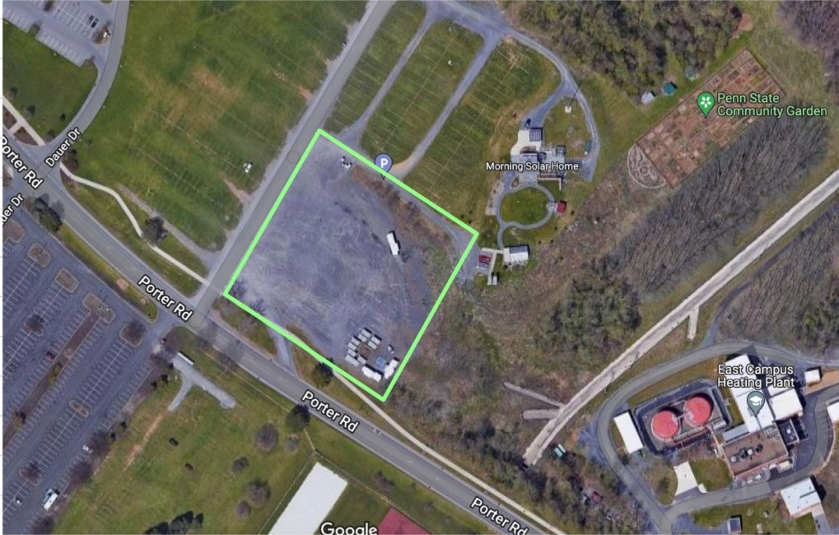

Section III
Directions for having a Vehicle
If you plan on having a vehicle in the parade, please contact VIPparade@psu.edu if you have any questions or concerns. You will be checking in at your allotted time with your vehicle on parade day at VIP/Vehicle grounds, in the gravel lot next to the Porter North Lot. Please see the map below for the location of the vehicle grounds. Once you have checked in, we require that someone is with the vehicle at all times, so please make sure you have a few people that can switch out with you so you do not have to be there all day. The parade captain in charge of your grounds will be placing you in the parking lot in a specific order to help us keep the parade in the correct order, so please do not move your car from that spot once you’ve parked your car unless told otherwise. As the start of the parade draws nearer, cars will start to line up in front of the “merge point”, to get the parade going. Please listen to the parade captain so everything can run as smoothly as possible. We do our best to make sure any walkers are with their correct cars, which is why it is very important to stay in the correct order. We look forward to having you in the parade this year!
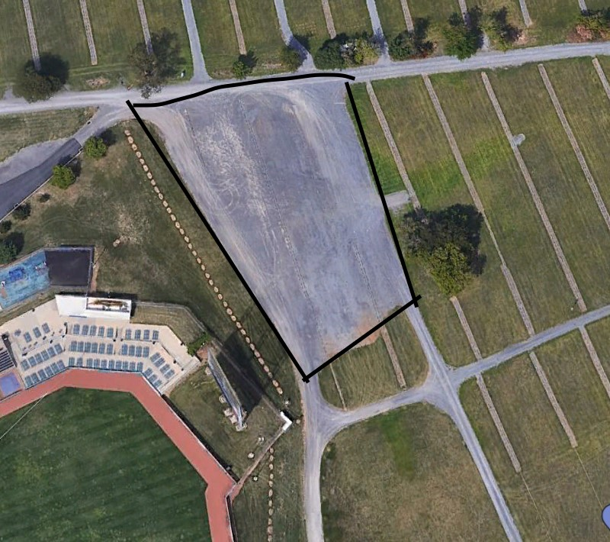

Section IV
Directions for walkers
For our walking groups, there will be two different points of communication, depending on what category you fall under. If you are a STUDENT organization, your main point of contact will be studentparade@psu.edu. If you are an ALUMNI/COMMUNITY organization, you will contact alumniparade@psu.edu. Check-in is also different for walking groups, depending on if you are a student organization or an alumni/community organization. Students will check in at Bigler Field, between the field hockey complex and McCoy pools. Please see the map below. For alumni/community organizations, check-in is located on the tennis courts in between the intramural (IM) building and Mckean Hall. Please see the map below. Remember to check-in with a parade captain at your allotted time, and always have someone in your area at all times. If your group also has a float or vehicle, you will be walking with them in the parade, so don’t worry! We’ve worked it out to make sure everyone can walk their groups, but in order to make sure that happens, please make sure you are listening to the homecoming captains in charge of your area. We are so excited to have your organization in the parade this year!
Student organization check-in Area: Alumni/community organization check-in Area:
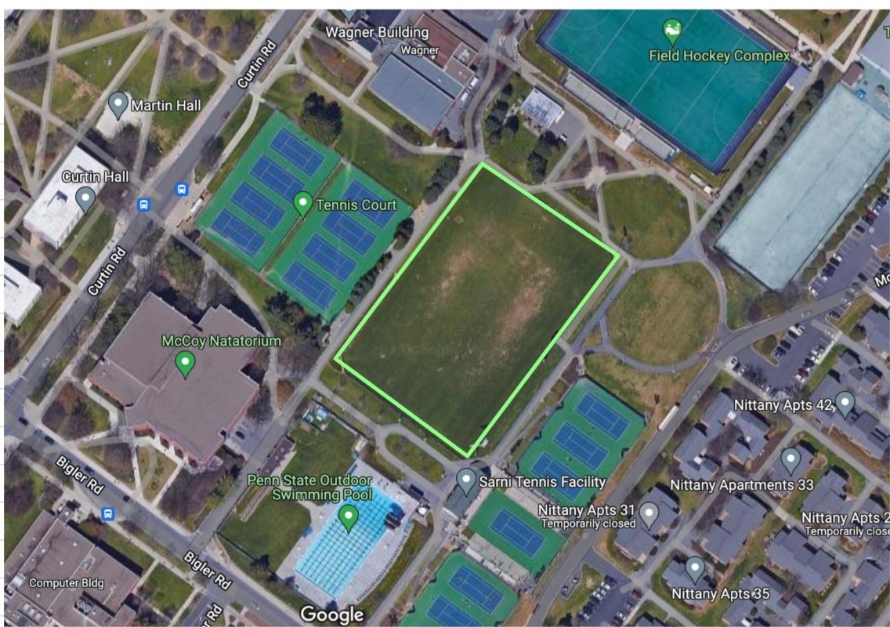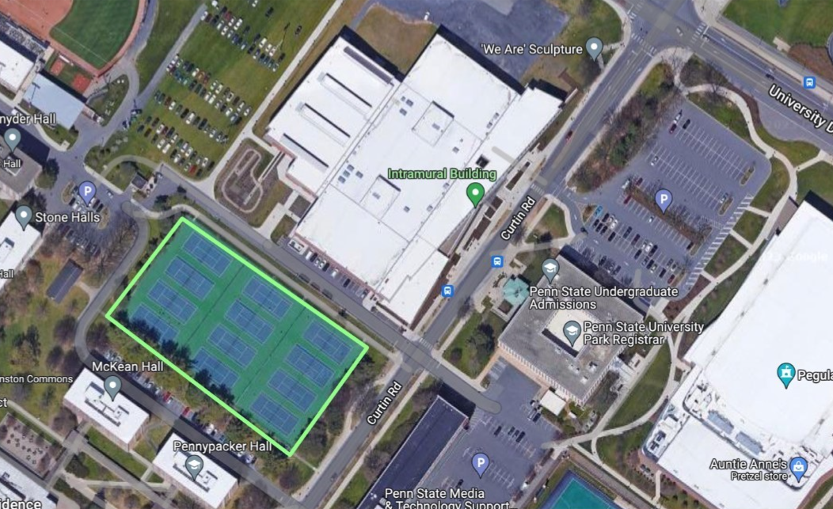

Section V
Payment options and Cost
The cost of participating in the parade as a community member or alumni group is $50 per 25 people. If you plan on having more than 25 people in your organization participate, up to 50 people, you will pay $100. If you would like to have more than 50 people participate, the cost will be $150. The payment should be a check made out to Penn State Homecoming, and either mailed to our homecoming office or handed in in person. The address of our office is 227B HUB, University Park, PA, 16802.
Section Vi
- Expectations
    - An organization that chooses to participate in Penn State Homecoming represents the University and will always abide by the Penn State Student Code of Conduct. By registering to participate in any Homecoming event(s), organizations agree to abide by the Student Code of Conduct, Policies, and Rules for Student Organizations, and to follow the rules and regulations set forth in the Homecoming Guide. The student code of conduct can be found at http://studentaffairs.psu.edu/conduct/codeofconduct/. Policies and Rules for Student Organizations can be found at http://studentaffairs.psu.edu/organizationrules.
    - Unruly or disruptive behavior or intoxicated participants will not be tolerated.
    - There is absolutely no standing on floats or vehicles at any time. All participants riding in the float or vehicle must remain sitting throughout the parade route.
    - Reckless driving is prohibited, vehicles may not drive side by side one another.
    - Political propaganda, profanity, alcohol/drug related references, and nudity are expressly forbidden.
    - Any inappropriate designs, performances, Madhatters, banners, or floats are prohibited

Section ViI
- Penalties
    - The Homecoming Executive Committee reserves the right to deny any participant(s) or organization(s) from participating in the Homecoming Parade.
    - The Homecoming Executive Committee reserves the right to disqualify any inappropriate behavior.
    - No decisions made by Homecoming Captains or Committee Members are binding and any such decisions are subject to review by the Homecoming Executive Committee.
    - All rules and regulations are subject to change at any time at the discretion of the Homecoming Executive Committee. Any modifications or additions to the rules and regulations of the Homecoming Guide will be publicized via the Homecoming listserv and the Homecoming website.
    - If any member of a participating organization is found to be intoxicated or acting inappropriately during the Homecoming Parade, the Executive Committee reserves the right to remove that person and their organization from the parade without warning.
    - In addition to disqualification, persons or organizations may be subject to penalties from the University or State College authorities.
    - Any organization participating in reckless driving during the parade will be subject to disqualification and penalties from State College Authorities.
    - Organizations will be held responsible for their actions leading up to and on parade day. Penalties incurred due to failure to attend required meetings and events or failure to comply with the rules set forth by the Homecoming Executive Committee will be monitored closely and can change whether your organization can participate in the parade.
    - All organizations that violate the rules and guidelines set in place in the 2024 Homecoming Parade Guide are subject to an automatic review by the Homecoming Executive Committee and can have their participation in Homecoming 2024 revoked or their future participations restricted.
By participating in the 2024 Homecoming Parade, I accept and acknowledge the terms set forth of being a participant.

